CareOwn HMS — User Manual & Administrator Guide

Part 1 of 3: Product Overview, Super Admin Guide, Client Admin Guide, Navigation Map
Written for hospital administrators and platform administrators. No technical background required. Every screen, field, button label, and rule described here was verified directly against the CareOwn HMS application code — where a commonly-expected feature doesn't yet exist in the system, this manual says so plainly.

Table of Contents
- Product Overview
- Super Admin Guide
- Client Admin Guide
- Navigation Map

1. Product Overview

1.1 Introduction
CareOwn HMS is a cloud-based Hospital Management System that runs a hospital's front desk, outpatient (OP) consultations, inpatient (IP) admissions, laboratory, pharmacy, billing, and insurance claims from one connected application. It is built as a genuine multi-tenant SaaS platform — a single CareOwn deployment can serve many independent hospitals, clinics, or labs (each called a "Client"), with each client's patient data, staff, and settings kept in its own dedicated, physically separate database. One client can never see or affect another client's data.

The system is made up of three separate applications working together:

- The Admin Application — what hospital staff use every day (patient registration, appointments, billing, lab, pharmacy, IP admission, reports, and administration).
- The Public Website — an optional, per-hospital public-facing website (appointment requests, doctor listings, health packages, news, blog) that a Client Admin can manage through the same Admin Application's Website CMS section.
- The Super Admin Console — a separate, platform-level application used only by CareOwn's own team to onboard new hospital clients and manage licensing (Chapter 2).

1.2 Key Features
- Patient registration with a searchable, de-duplicated patient registry
- Appointment booking with live doctor-availability slots, plus a walk-in Direct Visit billing path
- An optional live Doctor Queue (token/check-in) system with a public kiosk display board
- OP consultation documentation (case sheets, vitals, diagnosis, prescriptions)
- Full inpatient (IP) admission workflow — registration, ward allocation, ward change, running IP billing ledger, two-stage discharge, and a clinical discharge summary
- A complete laboratory workflow — test catalog, requisition, technician result entry with approval locking, and reporting
- A complete pharmacy workflow — purchasing, goods receipt (stock intake), point-of-sale style billing with real stock deduction, sales returns, and stock adjustments
- ICD-10/ICD-11 diagnosis coding per patient visit
- Insurance pre-authorization, approval, claim, and rejection tracking
- Cashier approval workflow for IP advance payments and settlements
- Role-based access control down to individual screens, with a configurable post-login landing page per role
- Per-client visual branding — colors, logo, favicon, login screen background, and sidebar styling — with light/dark mode
- An executive CEO/MD Dashboard with IP/OP revenue and activity charts, alongside a simpler day-to-day MIS Dashboard
- Secure, patient-report file sharing via a time-limited WhatsApp link

1.3 Benefits
- One system, every department. Front desk, doctors, lab, pharmacy, billing, and management all work from the same patient record instead of separate, disconnected tools.
- Nothing to install. Runs in a web browser; a new staff member needs a username and password, not IT setup on their machine.
- Safe by design for multi-hospital groups. Because each client's data lives in its own database, there's no risk of one hospital's staff ever seeing another hospital's patients — this is a structural guarantee, not a setting someone could get wrong.
- Looks like your hospital, not a generic template. Every client can set their own logo, colors, and branding without needing a developer.
- An audit trail where it matters. Patient registration, billing activity, IP admissions, and staff account changes are all separately logged with who-did-what-when.

1.4 User Roles at a Glance
CareOwn HMS does not hardcode job titles — every permission is assigned through the Roles screen (Chapter 3), so a hospital can shape roles exactly to how their staff actually work. The roles below are the typical pattern most hospitals set up, referenced throughout this manual:

Role | Typical responsibilities
Receptionist | Patient registration, appointment booking, check-in, walk-in billing
Doctor | Doctor Dashboard queue, OP case sheets, prescriptions
Nurse | Vitals entry on case sheets, ward/IP support
Lab Technician | Test entry, result approval, report printing
Pharmacist | Purchase, stock receipt, pharmacy billing, returns
Billing / Cashier | OP/IP payment approval, refunds, collection reports
Client Administrator | Everything in Chapter 3 — masters, users, roles, theme
Super Admin | Platform-level — onboards hospitals (Chapter 2)
Note: A Role controls two things at once: which modules a staff member sees in the side menu, and — optionally — which specific screens within a module. A Role can also be given a default landing page, so (for example) a Lab Technician's role can be set to open straight to the Lab Entry Queue after login instead of the general Dashboard. See section 3.6.

1.5 How the System is Organized (Functional View)
Every hospital client's data is completely isolated in its own database. One CareOwn HMS installation can host many hospitals; a hospital's staff only ever sees their own hospital's data, automatically, based on how they log in.

Layer | What it does
Super Admin Console | CareOwn's own team onboards each hospital as a "Client," licenses which modules they've purchased, and sets up their first login
One Client (= one hospital/lab/clinic) | Has its own dedicated database — its patients, staff, appointments, bills, and settings never mix with any other client's
Client Administrator | Configures their own hospital — departments, doctors, staff accounts, roles, branding, and master data
Everyday staff | Log in with a username/password issued by their Client Administrator and see only the modules their Role permits

2. Super Admin Guide
The Super Admin Console is a separate application from the one hospital staff use, reached at a different web address and with its own login. It exists to onboard new hospital clients onto the platform and manage what each one has licensed. This chapter is written for CareOwn's own platform team, not hospital staff.

2.1 Logging in as Super Admin
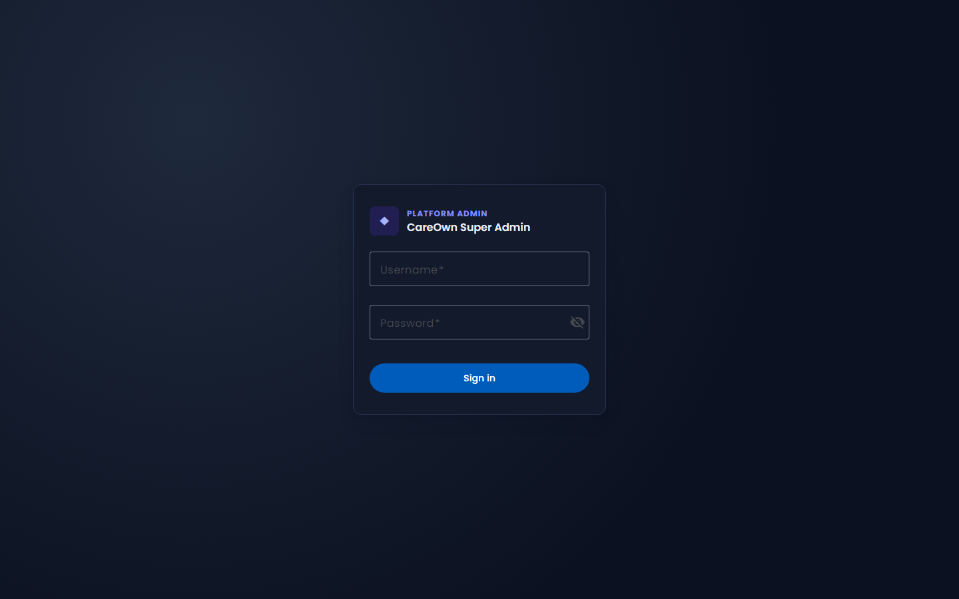
Super Admin login screen

Navigation: Open the Super Admin login page directly (a separate URL from the staff login)

Enter your Super Admin username and password. This is a completely separate credential from any hospital's own staff logins — a Super Admin account belongs to no client and cannot log into any hospital's regular Admin Application.

Warning: Super Admin access should be limited to a small number of trusted platform administrators. A Super Admin can license or unlicense any module for any hospital and suspend a hospital's access entirely.

2.2 Creating a New Client (Hospital / Lab / Clinic)
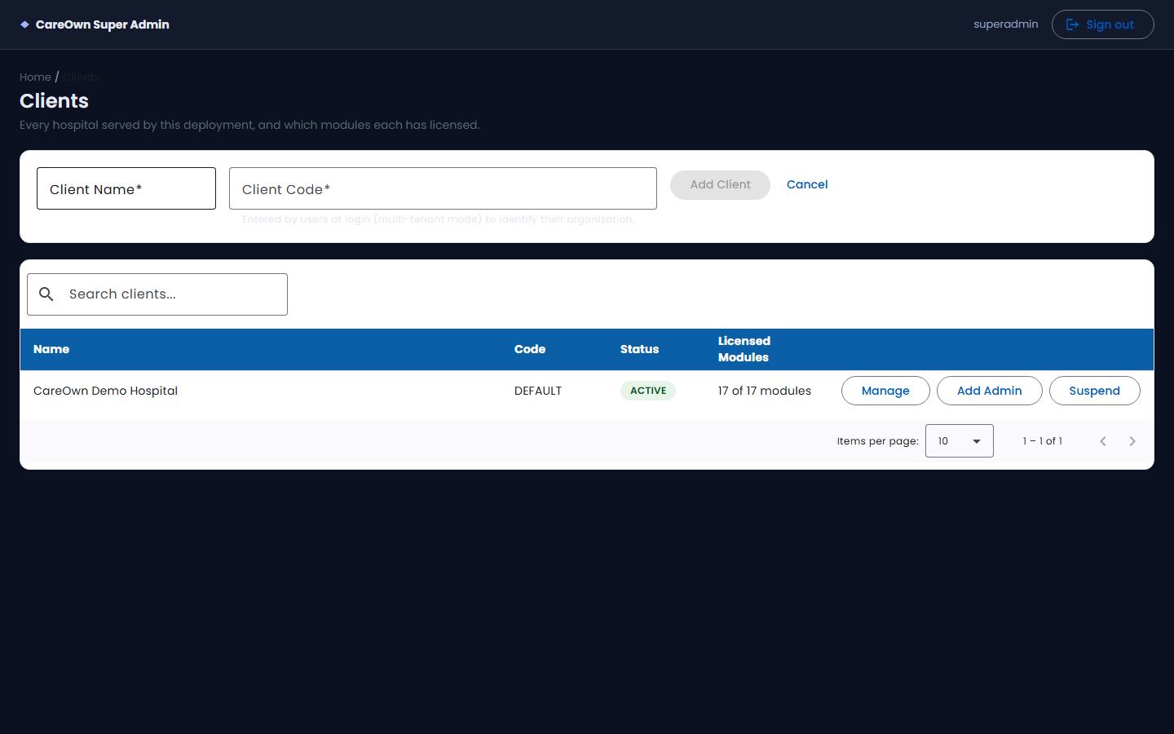
Creating a new client from the Super Admin portal

Navigation: Super Admin Console → Clients

- Click Add Client on the Clients list.
- Enter the Client Name (the hospital's full name) and a short, unique Client Code — this code is what the hospital's own staff will type into the login screen's "Client Code" field once the deployment is running in multi-tenant mode.
- Save. The new client is created with status ACTIVE and is automatically granted the three modules every client always needs: Overview, Masters, and Administration.

Important: Creating a client here does not create their database yet — that is a separate step (2.7, Provisioning the Database). A newly created client has no working login until its database exists and a first administrator has been bootstrapped (2.6).

2.3 Licensing Modules for a Client
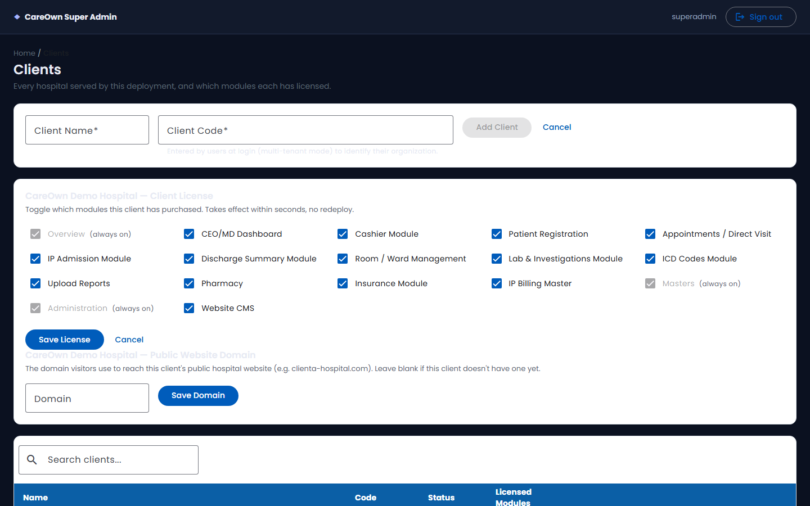
Toggling licensed modules and setting the public website domain for a client

Navigation: Clients → select a client → Modules

You'll see a checkbox for every module in the system (Patient Registration, Appointments, IP Admission, Lab, Pharmacy, Insurance, and so on). Tick the modules this client has purchased/is entitled to use, then save. This is a full replace — saving sends the complete new list of licensed modules, not just the ones you changed.

The effect is immediate: hospital staff at that client will lose access to a module the moment it's unlicensed, and a module reappears in their side menu the moment it's licensed again (within a short caching delay, typically under a minute).

Note: Licensing a module here only controls whether it's available to the client at all. Whether a specific staff member can see it is controlled separately, by that client's own Roles setup (Chapter 3.6) — a module must be both licensed by Super Admin and granted by the staff member's Role for them to actually see it.

2.4 Suspending / Reactivating a Client
Navigation: Clients → select a client → Status

A client has exactly two statuses: Active and Suspended. Suspending a client immediately blocks every new login attempt by that hospital's staff — existing open sessions are not forcibly ended, but no one can sign back in until the client is reactivated.

2.5 Setting a Custom Website Domain
Navigation: Clients → select a client → Domain

If this client has their own public hospital website hosted on this platform, set their domain here (e.g. www.examplehospital.com). This is what routes a visitor to that hospital's public website content instead of any other client's.

2.6 Creating the Client's First Administrator
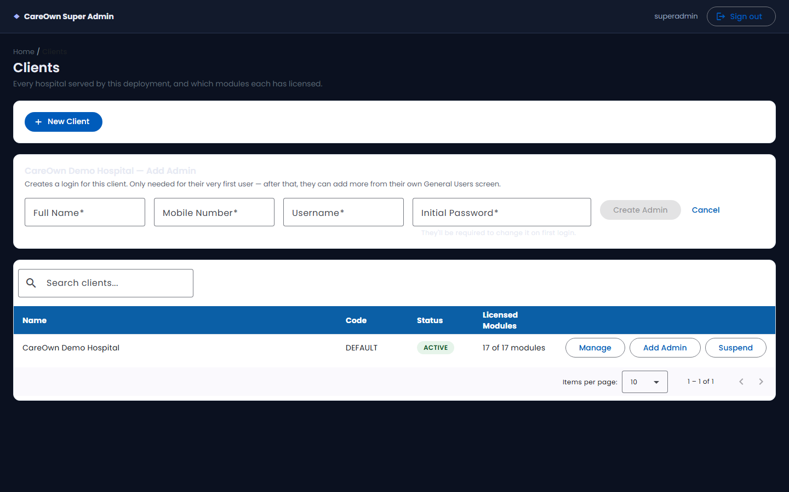
Bootstrapping a client's first administrator account

Navigation: Clients → select a client → Create Admin User

This is a genuine one-time onboarding action — it exists purely to get a brand-new hospital's very first login working. Enter the new administrator's name, mobile number, a username, and an initial password. The account is created with an "Administrator" role (every module permitted) and is forced to change its password on first login.

Warning: Every other staff account after this first one must be created by the hospital's own Client Administrator through the normal General Users screen (Chapter 3.5) — Super Admin does not create ordinary staff logins.

2.7 Provisioning the Client's Database
Navigation: Clients → select a client → Provision Database

This is the step that actually creates the hospital's dedicated database and brings it up to the current version of the system. It runs the platform's complete set of database setup scripts against a brand-new, empty database created just for this client. It is a synchronous, one-time action — expect it to take longer than an instant page load, since it's genuinely building a fresh database, not just flipping a flag.

You can check a client's database status at any time from the same screen; if provisioning ever fails partway, it is safe to run again for that same client.

2.8 What Super Admin Cannot Do Yet
To set accurate expectations, the following are not currently available in the Super Admin Console, even though they might be expected of a platform admin tool:

Capability | Status
Subscription plans / pricing tiers per client | Not available — a client's feature package is a one-time build-time setting, not something adjustable from this console
Editing or deleting a client's name/code after creation | Not available
Removing a client entirely | Not available — suspend is the closest equivalent
A usage/analytics dashboard across all clients | Not available
A built-in audit log viewer for Super Admin's own actions | Not available
Backup & restore tooling | Not available — handled outside the application, at the infrastructure level

3. Client Admin Guide
This chapter is for the person responsible for getting a hospital ready to use CareOwn HMS — usually the hospital's own administrator, once Super Admin has created the client and issued the first login (Chapter 2.6).

3.1 Initial Setup Checklist
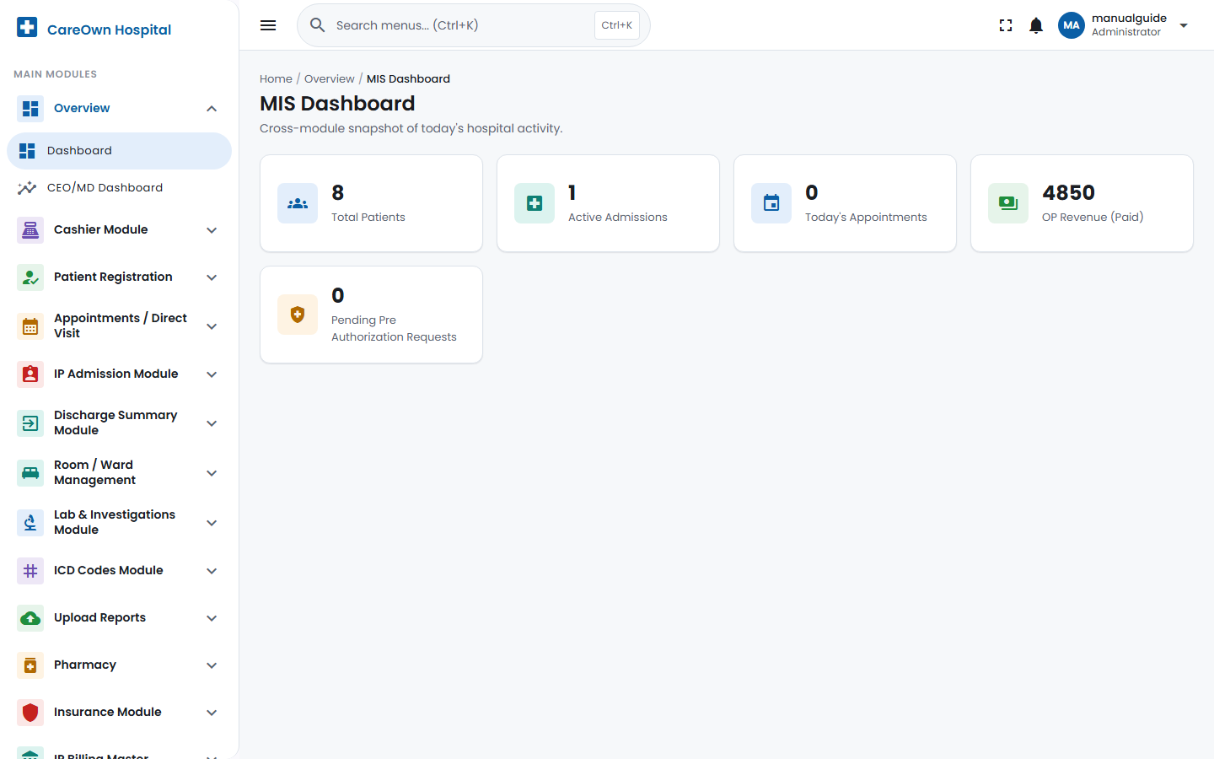
The MIS Dashboard, seen right after logging in as a Client Administrator

Do these roughly in this order — later steps depend on earlier ones:

- Log in with the credentials Super Admin issued, and change the temporary password when prompted.
- Fill in the Hospital Profile (Clinic Settings) — name, address, logo.
- Set up Departments.
- Set up Doctors (Consultants), including their specialization, department, fee, and weekly availability.
- Set up the master data each licensed module needs before it can really be used — billing categories/components, room types, lab test catalog, pharmacy product catalog, ICD codes, insurance companies, as applicable.
- Create Roles matching how your staff actually work, then create staff user accounts against those roles.
- Optionally customize the Theme — colors, logo, login screen background.

3.2 Hospital Profile
Navigation: Administration → Clinic Settings

This one screen covers three things: your hospital's identity (name, address, phone, logo — shown on every printed receipt), your public website configuration (if you have one), and your visual theme (Chapter 3.7). At minimum, set the Hospital name — everything else is optional but recommended before go-live, since the name and logo appear on every bill and report your staff print.

3.3 Department Setup
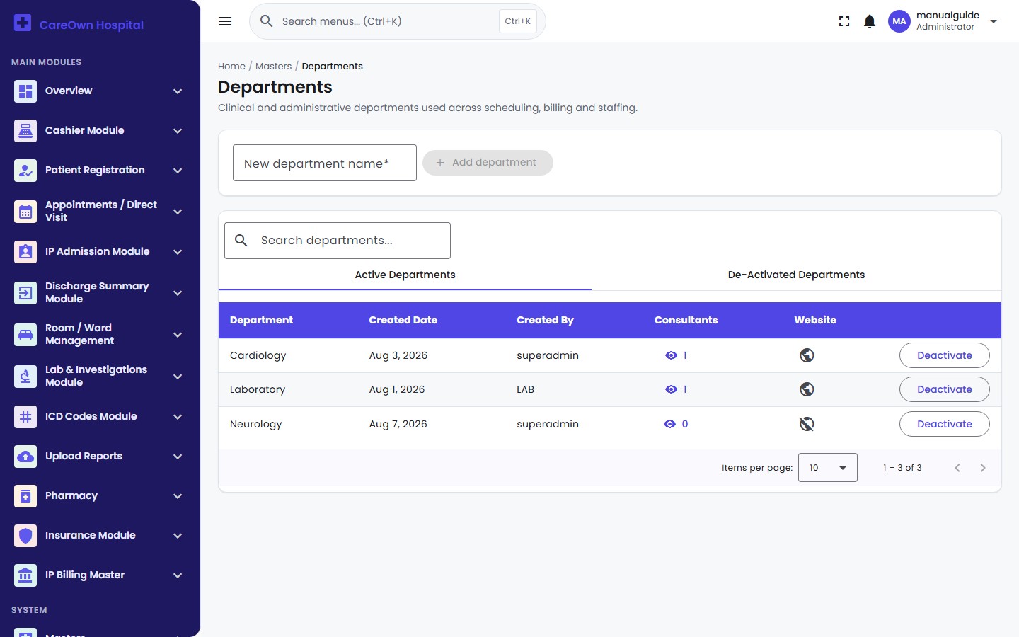
Department setup screen

Navigation: Masters → Departments

- Type the department name into the New department name field.
- Click Add department.

Departments feed the Doctor setup screen's Department dropdown, and can optionally be published to your public website. A department already assigned to a doctor is still safe to deactivate later — deactivating hides it from new selections without deleting history.

3.4 Doctor Setup
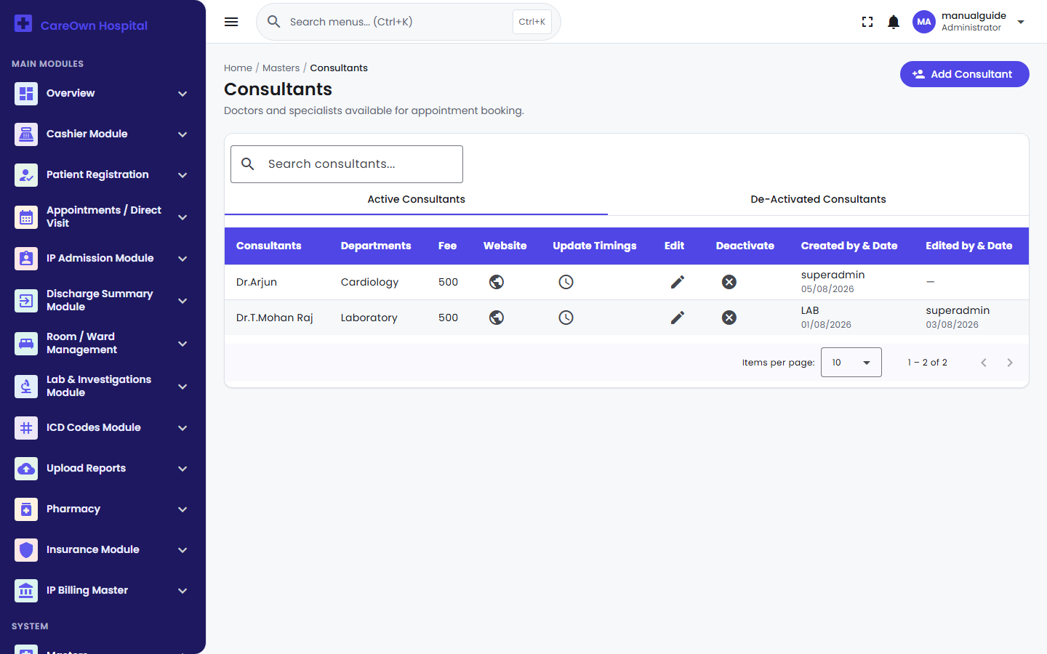
Doctor / Consultant setup screen

Navigation: Masters → Consultants

- Click Add Consultant.
- Fill in the doctor's name, specialization, and department (all required), plus consulting fee, mobile, email, and photo as available.
- Set Appointment status to Yes if this doctor should be bookable — this reveals the weekly availability grid.
- Fill in the Doctor Availability grid: for each day of the week, set a From/To time for whichever of the four fixed sessions (Morning 06:00–11:59, Afternoon 12:00–16:59, Evening 17:00–21:59, Night 22:00–05:59) the doctor actually works — leave a session blank on days they're off.
- Save.

Note: Saving the availability grid always replaces the doctor's entire week at once — there's no way to update just one day without resubmitting the whole grid. To change a doctor's schedule later, use the Update Timings icon on the Consultants list.

3.5 User & Role Management
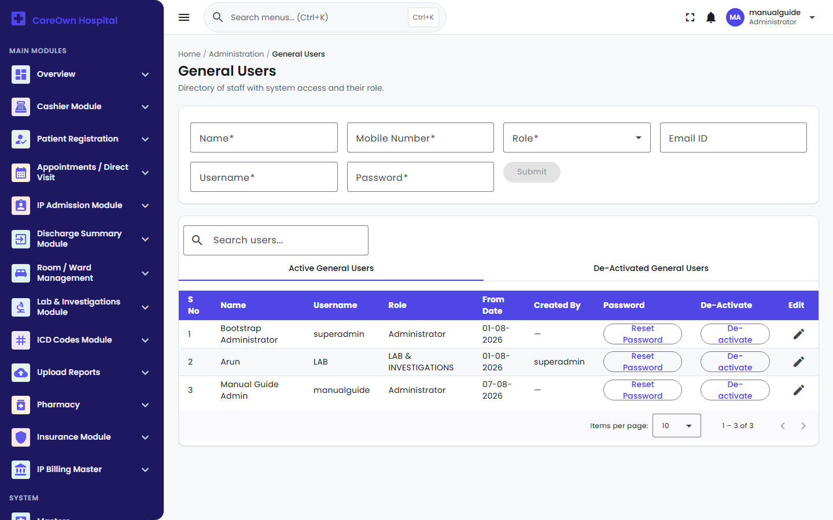
General Users screen

Navigation: Administration → General Users

This is where you create every staff login after the first one Super Admin issued. Each user needs a name, a 10-digit mobile number, a Role (see 3.6 — create roles first), a username, and an initial password. New staff are always forced to change their password on first login. You can reset a user's password at any time from the same screen (a Reset Password button on their row) — this also forces a change on their next login.

3.6 Roles & Permissions
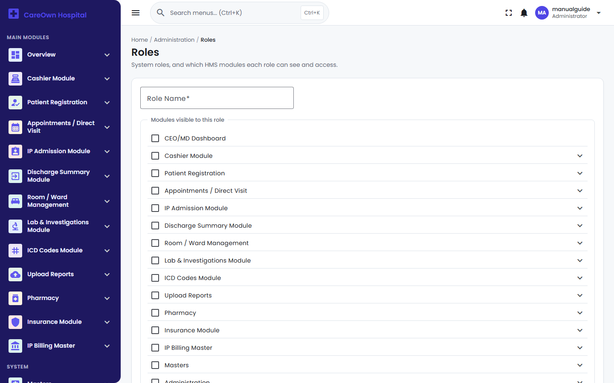
Roles & Permissions screen

Navigation: Administration → Roles

A Role decides three things for everyone assigned to it:

- Which modules appear in their side menu — a simple checkbox per module. (The Dashboard/Overview module is always available to every role and isn't shown as a checkbox.)
- Optionally, which specific pages within a granted module — expand a module's checkbox (the ▾ arrow) to reveal individual page checkboxes, letting you grant a module but restrict it to only certain screens (for example: give a role the "Appointments" module but only the Book Appointment and Appointments screens, not the audit-log pages).
- Where they land immediately after logging in — the Default page after login dropdown only offers pages the role can actually reach, so you can't accidentally send a role to a screen they don't have access to.

Tip: Build your Roles before creating staff user accounts — the General Users form requires picking a Role, so having your role structure in place first makes user creation a one-pass job.

3.7 Master Data You'll Need Before Go-Live
Depending on which modules your hospital has licensed, set these up before staff start using the corresponding module day-to-day:

If you use... | Set up first | Where
OP Direct Billing | OP Billing Categories & Components (walk-in charge price list) | Masters → OP Billing Categories / Components
IP Admission | Room Types and Room Numbers (with per-type cash/insurance daily rates) | Room / Ward Management
IP Billing | IP Billing Categories & Components | IP Billing Master
Laboratory | Lab Category → Sub-Category (the priced tests) → Component (the reported parameters) | Lab & Investigations Module
Pharmacy | Supplier, Manufacturer, Product Type, Rack, and Product masters | Pharmacy → Inventory Master
ICD Diagnosis Coding | ICD Code Master (or import a standard code set via CSV) | ICD Codes Module
Insurance | Insurance Companies list | Insurance Module → Insurance Companies

3.8 Theme Customization
Navigation: Administration → Clinic Settings → Appearance Settings

Pick a built-in preset for an instant, professional look, or fine-tune individual colors — primary, secondary, tertiary, the company-name text color, and (in the Advanced panel) header, footer, and menu colors independently. You can also set a custom background image for the login screen itself, so staff see your hospital's branding before they've even signed in. Changes preview live before you save, and can be exported/imported as a JSON file to copy a theme between hospitals.

3.9 Printing
There is no separate printer-configuration screen in CareOwn HMS. Every receipt, bill, and report has its own Print button, which opens your browser's normal print dialog — printer selection, paper size, and margins are controlled there, the same as printing any other web page. For a dedicated receipt printer, set it as your browser's default printer or select it each time from that dialog.

4. Navigation Map
Every module and screen in the Admin Application, exactly as labeled in the side menu, grouped the same way they appear on screen. Use this as a quick-reference index alongside Part 2's workflow chapters.

Menu Group | Screens inside it
Overview | Dashboard, CEO/MD Dashboard
Cashier Module | Dashboard, IP Approvals, Collection Report
Patient Registration | Patients, Patient Information (OP/IP), Review Date Report, Logs
Appointments / Direct Visit | Book Appointment, Reception Check-In, Doctor Dashboard, OP Direct Billing, Appointments, Patient Prescription, Collection Report, Refund & Report, Appointment Audit Logs, Doctor Queue Audit Logs
IP Admission Module | New Admission, IP Admissions, In Patient List, Discharge List
Discharge Summary Module | Discharge Initiated List, Discharge List
Room / Ward Management | Room Types, Room Numbers, Room Availability
Lab & Investigations Module | Lab Requisition, Lab & X-Ray/Scan Billing, Lab Entry Queue & Report, Lab Draft Report, Lab Approved Report, Lab Category/Sub-Category/Component, three Collection Reports, Payment Refund, Refund Report, Cancelled Report
ICD Codes Module | ICD Code Search, ICD Code Master
Upload Reports | Upload Reports, View Files, Audit Log
Pharmacy | Inventory Master, Purchase Management, Pharmacy Billing, Sales Return, Sales Return Approval, Stock Adjustment, Purchase Return, Pharmacy Reports
Insurance Module | Pre Authorization Requests, Insurance Approval Queue, Insurance Claim Report, Insurance Rejected Report, Insurance Companies
IP Billing Master | IP Billing Categories, IP Billing Components, Billing Activity Log, Consultant Wise Report, Admission Report, Advance Report, Advance Cancel, Cancelled Admissions, IP/OP Tracking Report
Masters | Departments, Consultants, Specializations, OP Billing Categories, OP Billing Components
Administration | Roles, General Users, Master Audit Logs, Clinic Settings
Website CMS | Site Content, Banner Slides, Gallery, News & Events, Testimonials, FAQs, Health Packages, Blog Posts, Career Openings
Note: Exactly which of these a given staff member sees depends on both (a) which modules your hospital has licensed with Super Admin (Chapter 2.3) and (b) what their own Role permits (Chapter 3.6). A screen missing from someone's menu is almost always one of those two settings, not a bug.

This is Part 1 of 3. Part 2 covers every end-to-end business workflow — Patient Registration through Billing, Insurance, IP Admission, Laboratory, and Pharmacy — with the exact fields, buttons, and validation rules for each screen. Part 3 covers Administration, Troubleshooting, FAQ, Glossary, a Go-Live Validation Checklist, and the Deployment Guide.

